**Working styles**

* A working style is basically how one conducts their work on a day to day basis. With the advancement of technology and the spread of the internet, they have affected people’s working styles all around the world especially for those in the teleworking sector.
* 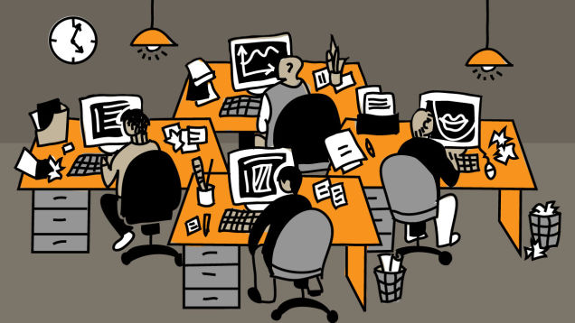With the growth of internet businesses are now offering teleworking jobs which more people find more convenient and which have really been easy for businesses to handle. It is fairly cheap for the company in terms of buying office facilities and also cutting down on transport costs and any other incurred costs.
* Only other disadvantage is that a higher percentage of people will lose their jobs if they are not skilled in this sector or if the company does not need any manually conducted work. The only requirements are a personal and a connection to the Internet, from there a worker is able to have the flexibility of working from where they find comfortable.
* This has also affected people’s ***Social*** life, now that people have more flexible hours of work they are able to get more done meaning that they have more time to relax and therefore use their time for socializing with friends and with others on social media.
* In their ***Personal*** life e.g. people are able to spend more time with their families and also has enough recreation time. Those with families are able to have longer recreation time with their children and are maybe also able to attend their school activities.
* Only major drawbacks with teleworking is if there is any problem in the connection to the internet that will be a major disadvantage to the one working because most work being done uses the internet